Coding Logic:

Leetcode Arrays

Target Sum: Easy

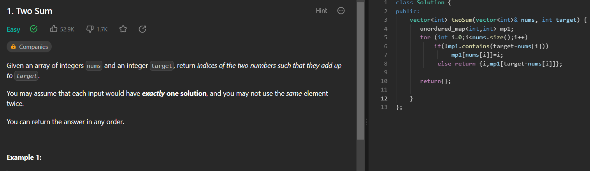

Number of Arithmetic Triplet: Easy
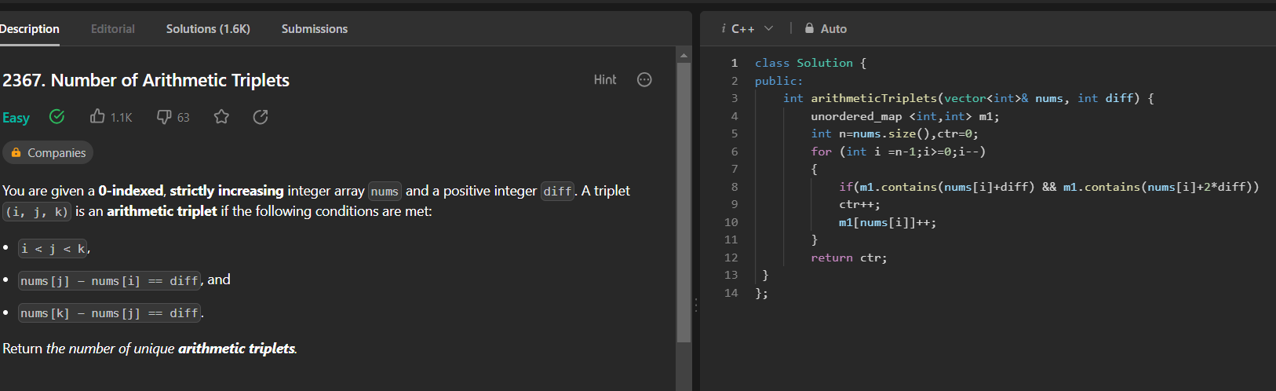

Sum of all odd length subarrays:

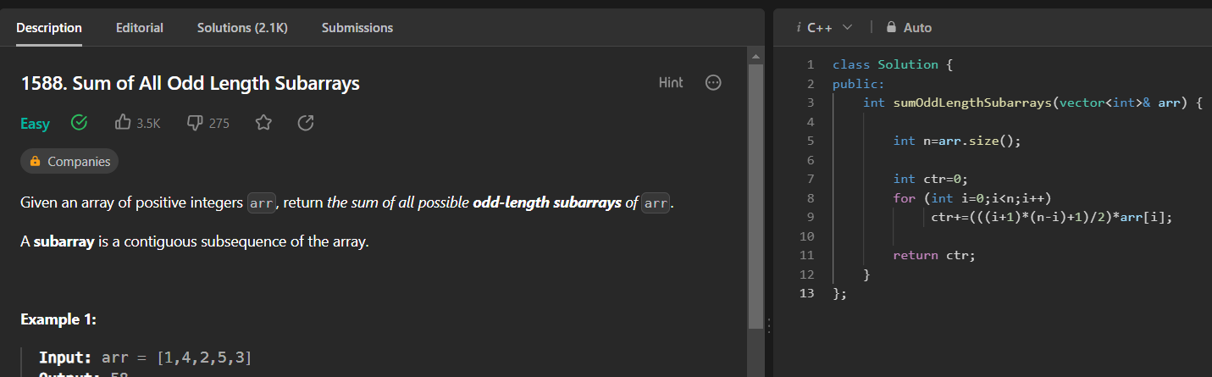

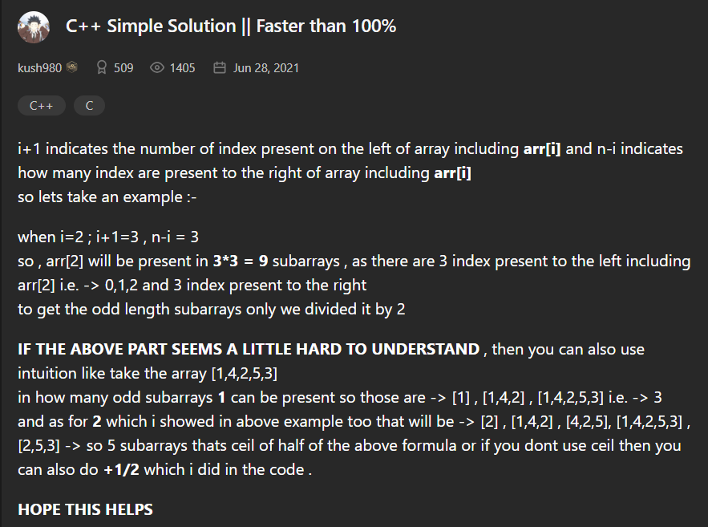

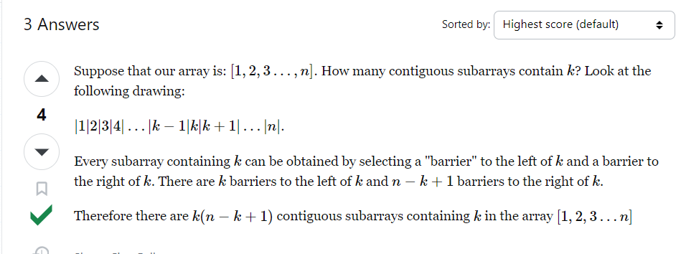

Count number of pairs with absolute difference k

Using Hashmap

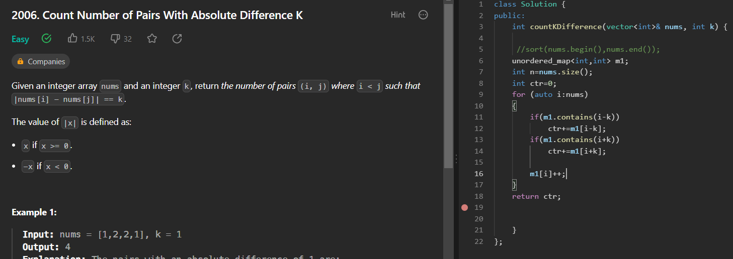

Using counting sort

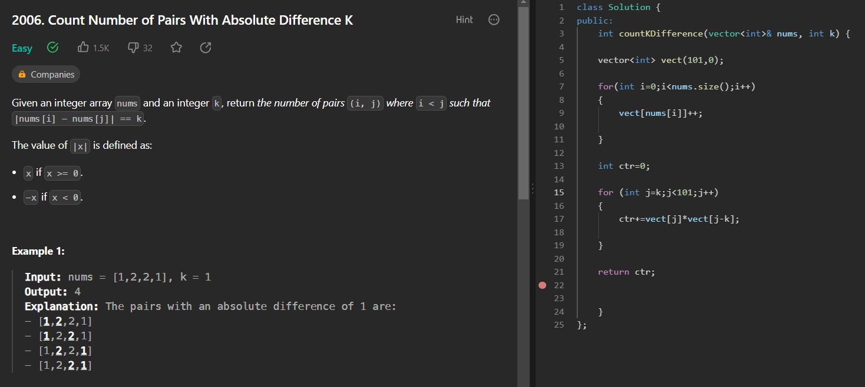

Largest local values in array:

No of subarrays of length k in an array is n-k+1.
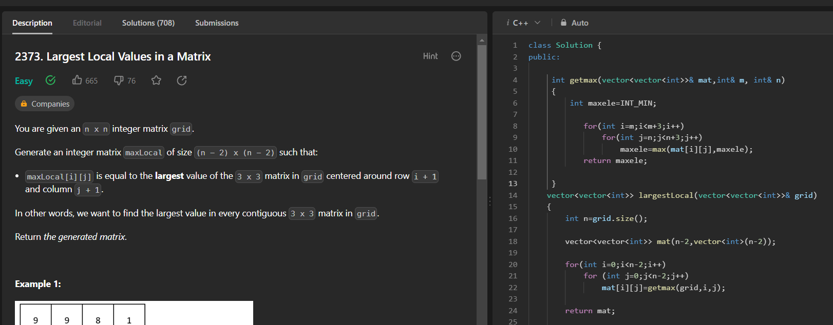

Number of distinct elements in a subarray:
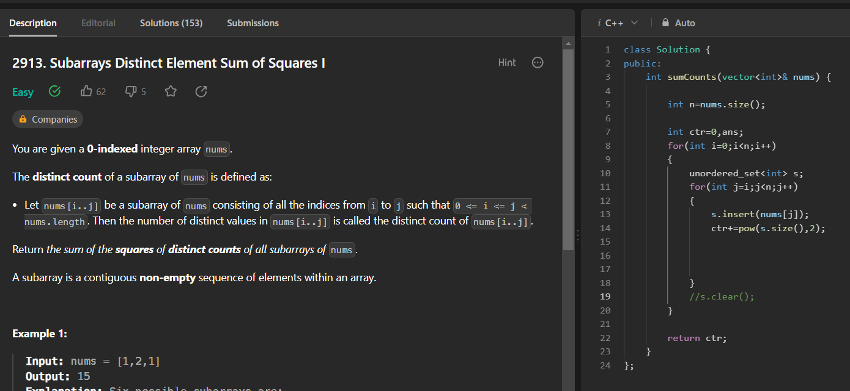

Retaining the memory of array.
- You can retain the memory of array like this:
Update the current element like this:

a=a+(b%n)*n
a/n will give the new number
a%n gives the old number.



